RA  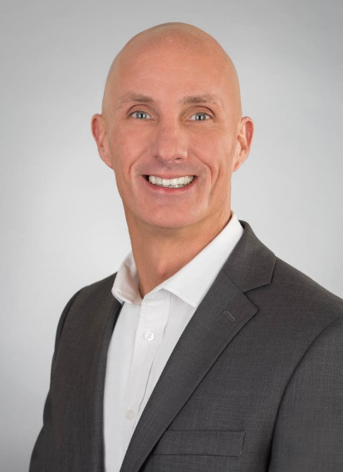  I am a results oriented and experienced Solution Sales professional with a proven consultative sales and leadership track record. Comfortable operating in highly competitive situations and diverse environments.  Seeking a challenging Strategic Account Management Position that would leverage my vast Enterprise and Commercial sales and channel experience coupled with my hardware, software, cloud (SaaS & API), mobility, telecommunications, network, and Internet of Things (IoT/M2M) background. | Bobby “Robbie” Austin, jr.  strategic account manAger  Experience  10/2017 to present Field2Base  Enterprise Sales Executive  - Currently manage 600 + Verizon representatives within in VES, WGB and Verizon Wireless.  - Developed a strategic and tactical business plan to grow Enterprise licensing and professional sales revenue.  - Leveraged HubSpot to manage and grow the Enterprise sales funnel forecast from $0 MRR to $60,000 MRR in 7 months  - New sales activities (pre/post) include cold call prospecting, account planning with Verizon MAM’s and CP’s via QBR’s and presentations, managed entire sales process – contracts/legal/pilots/POC & customer forms design.  7/2016 to 11/2016 Verizon Enterprise Solutions  Internet of Things (IoT) Solutions Architect  - Actively worked with Business Development and Southeast Market to identify, qualify, manage and close Verizon-Branded IoT Share solutions.  - Leveraged Salesforce.com and the markets to isolate, qualify and drive customer appointments to fill Share 2.0 sales funnel.  - Grew the Southeast Market IoT Share 2.0 Funnel of qualified leads over 100% in less than 5 months.  - Partnered with Product Development to gather customer requirements and develop Share 2.0 proposal document.  12/2012 to 7/2016 Verizon Wireless  Vertical Account Manager – Supply Chain  - Averaged 130% of quota for M2M and Traditional Activations  - Coached, Mentored and Educated front-line field sales teams on Supply Chain business challenges and legislation (ELD, FSMA, FMCSA, etc.)  - Conducted knowledge transfers and prospecting sessions with front-line field sales teams – transportation, distribution & manufacturing  - Organized, hosted and facilitated annual Vertically-focused Symposiums for the Southeast.  - Engaged Verizon’s echo-system of partners to help drive Verizon Wireless activations and revenue.  11/2010 to 12/2012 Verizon Wireless  State & Local Government Major Account Manager  - Managed and directed 13 State of North Carolina Executive Branch agencies mobility strategy and contracts  - Achieved 151% of quota  - In 2012 earned #7 Account Manager in Southeast and personally drove over 1M dollars of new recurring revenue.  - Hosted annual Strategic Executive Briefing sessions to help drive awareness and education of portfolio of Verizon Wireless and Partner solutions.  9/2007 to 11/2010 NC Office of Information Technology Services  Voice Messaging Service Specialist  - Overall responsibility for both the technology and the business functions of ITS Managed Voice Messaging services.  - Accountable for the overall technology direction and strategy, determining suitability for meeting State agency objectives, SLAs, and its ongoing solutions progression.  - Managed five (5) ITS Managed and two (2) Service Provider Voice Messaging platforms with over 17,000 State agency users.  - Grew receipts revenue 15% YOY, and generated over $700K in receipts.  4/2006 to 9/2007 Nuance Communications, Inc.  Regional Sales Manager  - Managed over 70 + Southeast accounts; built a sales funnel to over $2.5M; generated over $865K in new system and upgrade sales revenue.  - Collaboratively worked with partners, enterprise representatives, operations and legal teams to keep customers satisfied and close business.  - Utilized salesforce.com daily to maintain existing and prospective new accounts.  - Presented to existing customers and prospects (Director level and higher) to clearly articulate the value of speech enabled auto attendants.  10/2002 to 4/2006 Ronco Communications, Inc.  Account Manager  - Responsible for driving over $2M in revenue & $380K in profit revenue.  - Drove the signing of over $200K in annual reoccurring maintenance contracts, plus managed existing customers, which accounted for over $150K in reoccurring maintenance revenue.  - Actively worked with senior level decision makers to position an assortment of voice and data solutions.  - Partnered with Nortel/Cisco Direct Touch and District Sales Managers to identify and close voice and data opportunities.  Education  North Carolina Wesleyan College Rocky Mount, NC  - B.S., Business Administration  - Graduated Magna Cum Laude – 3.60 GPA  Skills  Business Acumen: ITIL Certified, Lean Six Sigma Champion, Cloud Computing, IoT Solution Selling, AXIOM Sales Methodology, Product Management, Salesforce.com Training, Nortel Qualified Sales Professional (QSP), Nortel Professional Telesales Training, IBM Signature Selling Method  Leadership: Seven Habits of Highly Successful People, and First Things First, Leaders Eat Last (Book), Leaders Eat Last (Book)  Technical Training: Introduction to MS Linc, MCS 5100 Champion Training, Meridian 1 & Succession 1000 Familiarization Succession 3.0 Test, Meridian 1 Options 11-81C Release 25 Familiarization, Approach IP Ready Certified, Voice Fundamentals, Data Fundamentals, IBM Netfinity and PC Server Fundamentals, Advanced Internet Business, Microsoft Outlook, Microsoft Excel, Microsoft PowerPoint, Lotus – Notes, 1-2-3, Freelance  References Available Upon Request

